# **UI/UX Design Plan**

## **১. Layout Overview**

### **প্রধান লেআউট স্ট্রাকচার:**

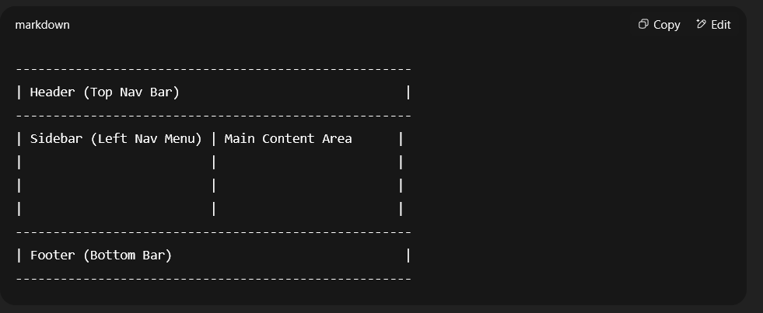

* **Header:**
  + লগো, নেভিগেশন আইটেমস, ইউজার প্রোফাইল আইকন, নোটিফিকেশন বেল।
  + Sticky/Fixed Top
* **Sidebar:**
  + Vertical menu, অ্যাপের সকল মেনু (Dashboard, Reservations, Rooms, Customers, Billing, Reports, Settings ইত্যাদি)।
  + Collapsible, Icons + Text
  + Mobile এ Hamburger menu আকারে হাইড হবে
* **Main Content Area:**
  + Dynamic content রেন্ডার হবে এখানে
  + Page Title, Breadcrumb, Action Buttons থাকবে
  + Responsive Grid & Cards ব্যবহার
* **Footer:**
  + ছোট্ট টেক্সট (©opyright info)
  + Sticky না হলেও চলে

## **২. Component Tree**

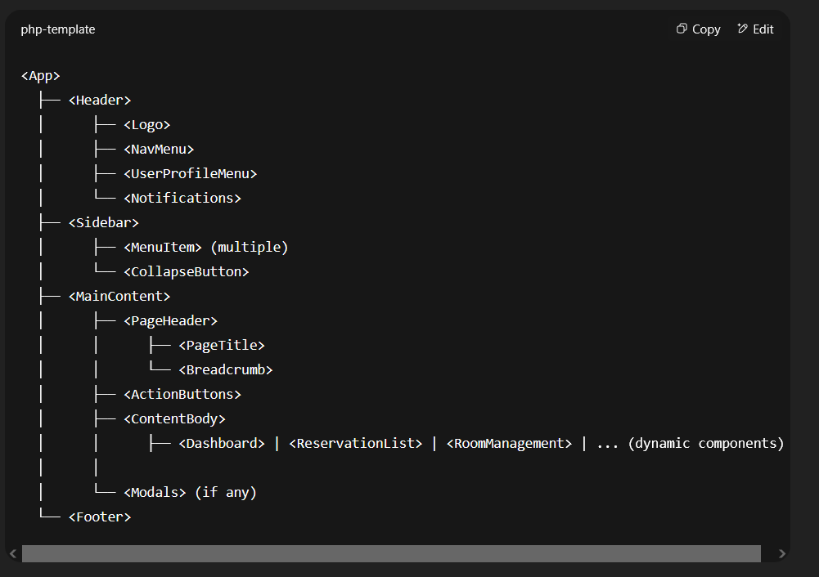

### **Key Components:**

* **Header:**
  + Global top navigation bar with quick access elements
* **Sidebar:**
  + Navigation panel with menu items and collapse toggle
* **MainContent:**
  + Holds the actual page content; flexible to load different modules dynamically
* **Footer:**
  + Static footer information

## **৩. Responsive Rules**

| **Device Type** | **Breakpoint (px)** | **Sidebar Behavior** | **Header Behavior** | **Content Behavior** |
| --- | --- | --- | --- | --- |
| Desktop (Large) | ≥1200 | Expanded Sidebar | Full Header Display | Multi-column layout, full width cards |
| Desktop (Med) | 992–1199 | Collapsible Sidebar | Full Header Display | Multi-column or 2-column grid |
| Tablet | 768–991 | Sidebar collapsed/hamburger | Header adapts (smaller icons) | Single column, stacked components |
| Mobile | <768 | Sidebar hidden, hamburger menu | Simplified header | Single column, vertical scroll |

### **Responsive UI Guidelines**

* **Sidebar:**
  + Desktop: Always visible (collapsed or expanded)
  + Tablet: Default collapsed; toggle to expand
  + Mobile: Hidden by default, Hamburger menu toggles sidebar drawer
* **Header:**
  + Icons shrink or hide on smaller screens
  + User menu accessible via tap
* **Content:**
  + Use Bootstrap’s responsive grid (row, col-sm, col-md, col-lg)
  + Cards and tables become scrollable on smaller widths
  + Fonts and buttons resize accordingly
* **Forms & Tables:**
  + Responsive inputs and buttons, stacked vertically on mobiles
  + Tables scroll horizontally inside a container

## **উদাহরণ: Responsive Sidebar Behavior in React (Pseudo code)**

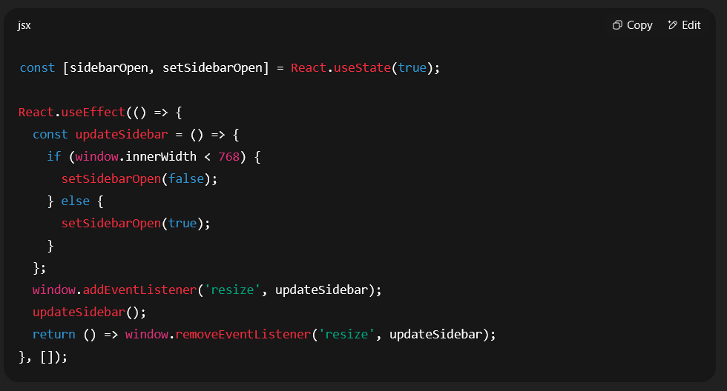

## **UI/UX Considerations Summary**

| **Aspect** | **Description** |
| --- | --- |
| Layout | Header + Sidebar + Content + Footer |
| Navigation | Sidebar menu collapsible & responsive |
| Content | Flexible, dynamic components |
| Responsiveness | Mobile-first, adaptive UI elements |
| Usability | Clear hierarchy, consistent spacing |
| Accessibility | Keyboard nav, ARIA roles |

চাইলে আরও ডিটেইল বা কোনো নির্দিষ্ট পেইজ/কম্পোনেন্টের UI/UX ডিজাইনও সাজিয়ে দিতে পারি।  
 কেমন লাগল?